**Vann – a Wildlife Tour**

*Project Report submitted in partial fulfilment of the requirements for the Degree of*

**BACHELOR OF TECHNOLOGY**

**in**

**COMPUTER SCIENCE AND ENGINEERING**

|  |  |
| --- | --- |
| By |  |
| **Shivani** | **11701620** |
| **Abhishek verma** | **11702561** |
| **Sumit Kumar** | **11701545** |
| **Vivek Tiwari** | **11702815** |
| **Atharva Hatekar** | **11702970** |

**Section: KMO76**

Under the guidance of

**Neha Sharma**



**School of Computer Science and Engineering**

Lovely Professional University

Phagwara, Punjab (India)

NOV 2019

**ACKNOWLEDGMENT**



We would like to thanks our Front-End Web Development teacher Ms. Neha Sharma for giving us this project work in web-development for designing and creating an interactive website.

“Vann – a Wildlife Tour” is the name we have given to our website which is a web-based tour / exploration of wildlife across India and the world. This website includes a short and must watch wildlife tour along with key information about some popular wildlife sanctuaries, parks, reserves and museums of India and across the world.

This project is a complete mixture of Web-technologies HTML, CSS, JavaScript and JQuery combined together in a best possible way to provide users an awesome experience with user-friendly interface and navigation.

While designing and building this website we came across various reliable features and built-in methods provided by front-end web-technologies like CSS3, JavaScript and jQuery that really helped us to achieve such a milestone.

This project is a team work of following students of B.TECH CSE department at Lovely professional university

|  |  |
| --- | --- |
| Shivani | 11701620 |
| Abhishek Verma | 11702561 |
| Sumit Kumar | 11701545 |
| Vivek Tiwari | 11702815 |
| Atharva Hatekar | 11702970 |

Place : Lovely Professional University Teacher: Ms. Neha Sharma

Date : 1st Nov 2019

**Table of Content**



**CONTENTS** **PAGE NO.**

**Cover Page** **1**

**Acknowledgement** **2**

**Table of Content** **3**

**Chapter 1. Introduction** **4**

1.1 Description 4

1.2 Design 4

**Chapter 2. Technology / Modules used…….….…………………………………….….5**

**Chapter 3. Design and Implementation…….….…………** **……………………….….5**

3.1 Flow chart 4

3.2 Screenshots 4

**Chapter 4. Codes…………………………….….…………………………………….….5**

**Chapter 5. Version Control and Hosting…….….…………………………..……….….5**

**1. INTRODUCTION**



**1.1 Description**

Our project “Vann – a Wildlife Tour” is a website consist of about 15 webpages which is

designed to prove a virtual web-based tour / exploration of wildlife across India and the

world. This website includes a short and must watch wildlife tour along with key

information about some popular wildlife sanctuaries, parks, reserves and museums of India

and across the world.

The goal of this project is to understand working of front-end web technologies in real

world. This project focuses on getting familiarized with combining popular web

technologies to achieve required web-designs and features.

Our website is hosted and available on: http://vann.ml

**1.2 Design**

This project is designed to provide a fresh, short and must known facts about some popular wildlife biosphere across the world.

This project is completely made using front-end web technologies like HTML, CSS, JavaScript and jQuery combined together in a best possible way to provide users an awesome experience with user-friendly interface and navigation.

This project or website includes a landing page which takes user to the home page which contains a brief of all main features of the website in form of header and drop-down menu. Home Page also contains a button which is a gateway to virtual wildlife tour.

The virtual wildlife tour and each webpage is enriched with cool animations using CSS3 and jQuery to provide users a good user experience.

This project focuses on users of all age groups, as it is built with an easy to understand interface that helps users to easily navigate and browse through the contents.

This Website is incorporated with well animated menu and icons based navigation interface system that helps user to quickly navigate or find out their desired content using menu and icons on the website.

**2. TECHNOLOGY / MODULES USED**



Front-end Web technologies used in this project are:

* HTML-5
* CSS-3
* JavaScript
* jQuery

This website is consisting of about 15 webpages and 7 main modules which serves the following features:

|  |  |  |  |
| --- | --- | --- | --- |
| **Sr.** | **Modules** | **Components** | **Purpose** |
| **No** |  |  |  |
| 1 | Landing Page | Animated title | Gateway to |
|  |  |  | Homepage |
| 2 | Homepage | Header | Button to start |
|  |  | Animated | virtual tour |
|  |  | background | Glimpse of all |
|  |  | Virtual tour button | features |
|  |  | Website brief |  |
|  |  | Footer |  |
| 3 | Tour page | Animated virtual | Virtual wildlife tour |
|  |  | tour play | / game. |
|  |  | Tour control system |  |
| 4 | Sanctuaries | Kanha Sanctuary | Key Details |
|  |  | page | Images Slide Show |
|  |  | Chinnar Sanctuary | Map view |
|  |  | Page | Artifacts |
|  |  | Bhadra Sanctuary |  |
|  |  | Page |  |
| 5 | National Parks | Gir Park page |  |
|  |  | Kaziranga Park |  |
|  |  | Page |  |
|  |  | Dachingam Park |  |
|  |  | Page |  |
| 6 | Wildlife Reserves | Nilgiri Reserve |  |
|  |  | Page |  |
|  |  | Nandadevi Reserve |  |
|  |  | page |  |
|  |  | Sunderban Reserve |  |
|  |  | page |  |
| 7 | Museum of Natural History | Washington, DC |  |
|  |  |  |  |
|  |  | New York |  |
|  |  | Melbourne |  |
|  |  | Australia |  |

**3. DESIGN AND IMPLEMENTATION**



**3.1 Flow Chart**

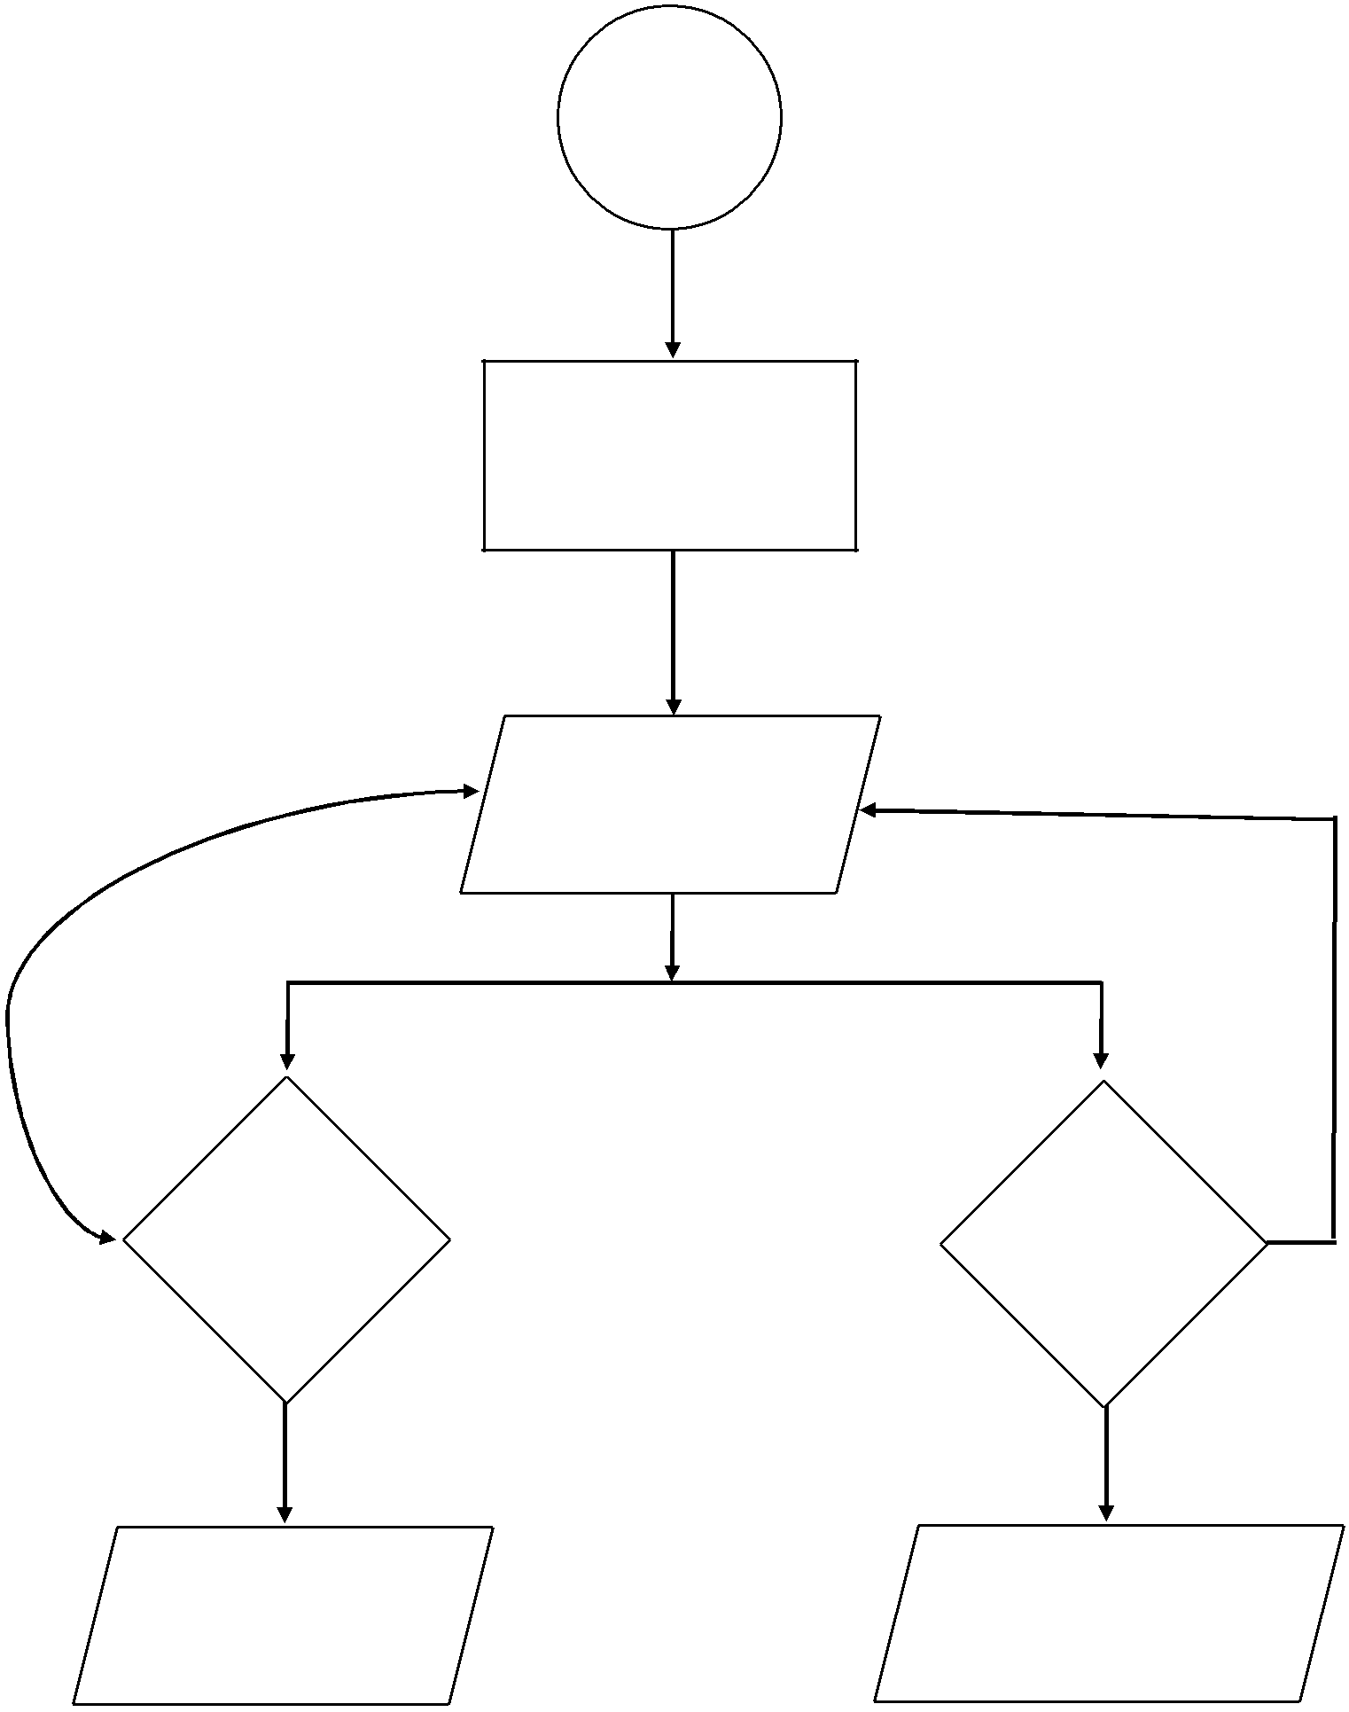

START

Landing Page

Default redirection

Home Page

Start Tour Explore

|  |  |  |
| --- | --- | --- |
| Tour page | Parks, Sanctuaries |  |
| Museums, Reserves |  |
| https://vann.ml |  |
|  |  |

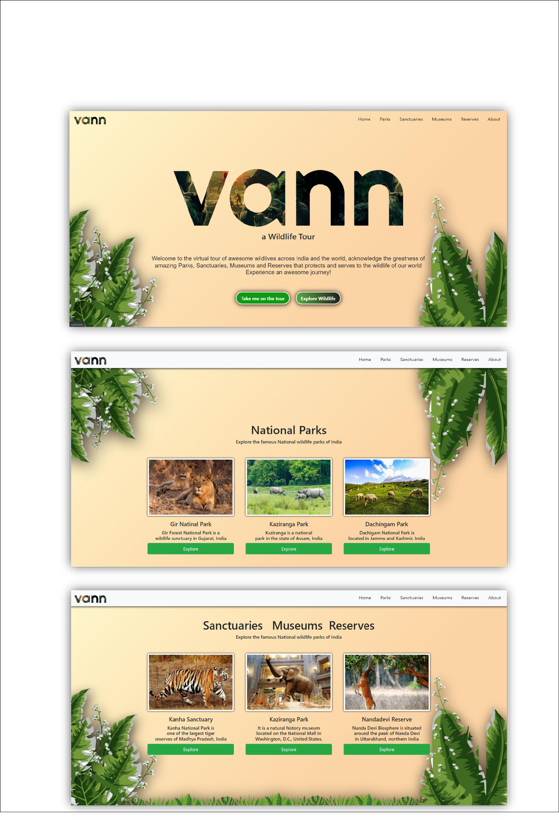

**3.2 Screenshots**

Home-Page (Desktop Site)

Home-Page (Mobile Site)

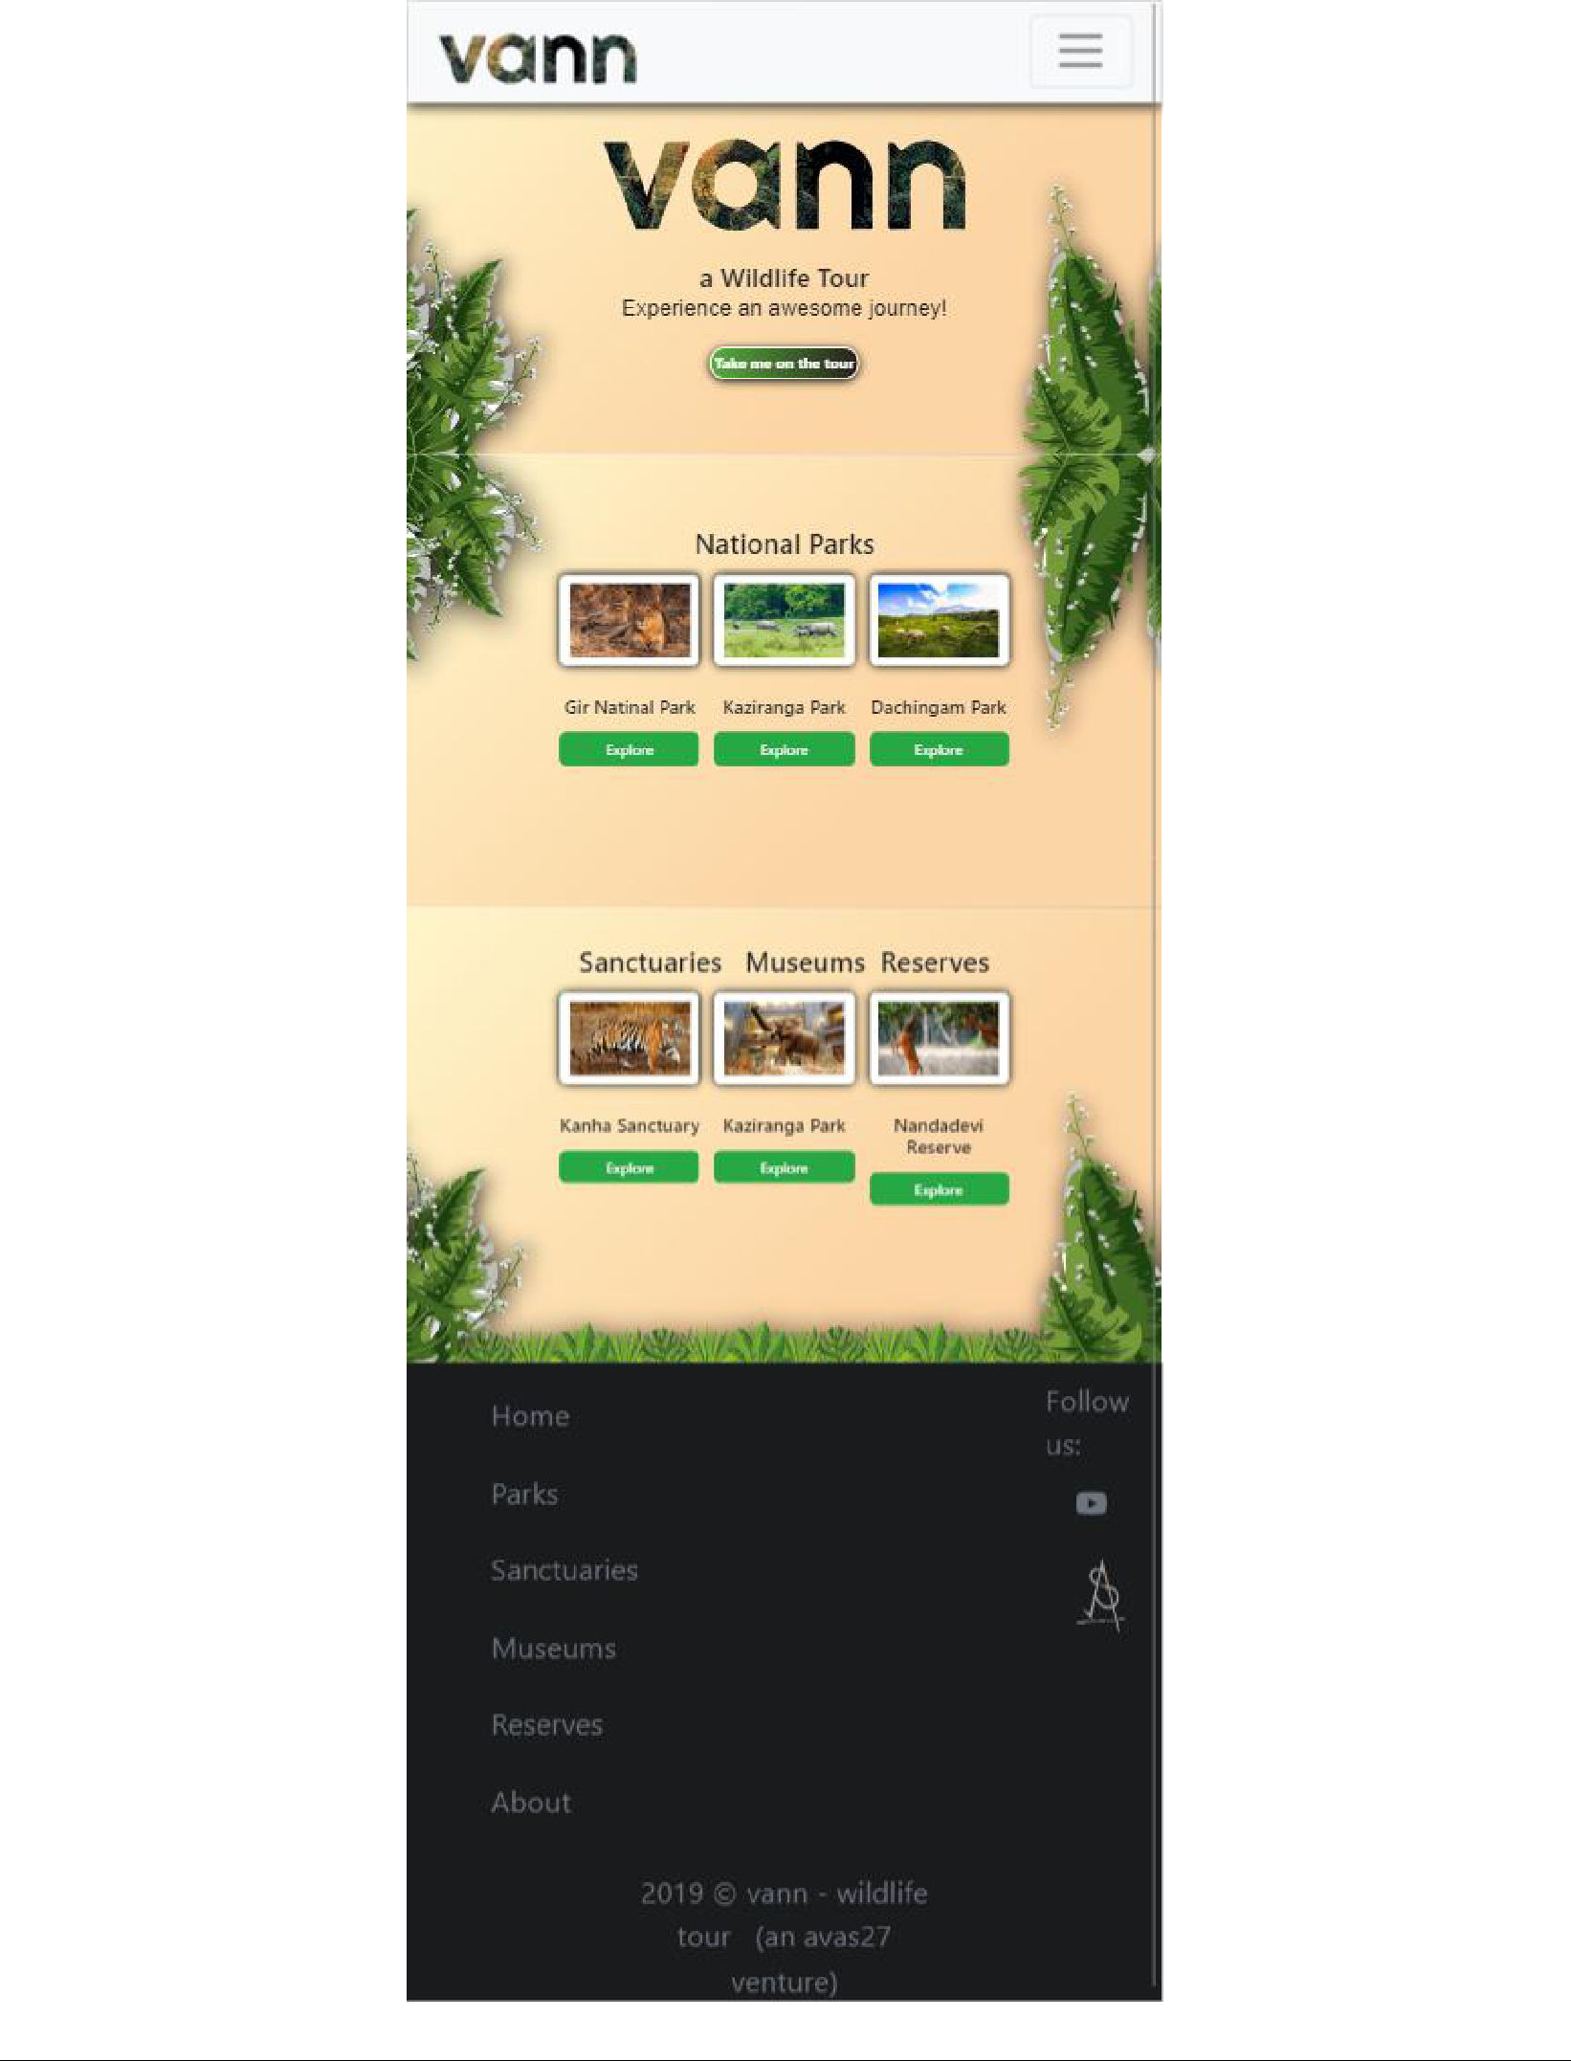

Tour Website (Desktop Site)

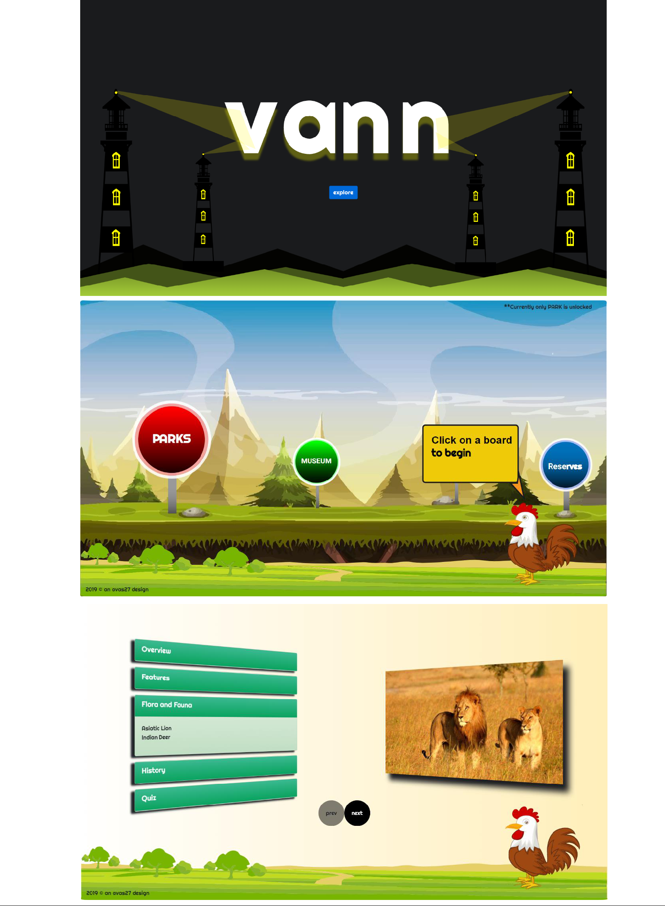

Exploration Parks (Desktop Site)

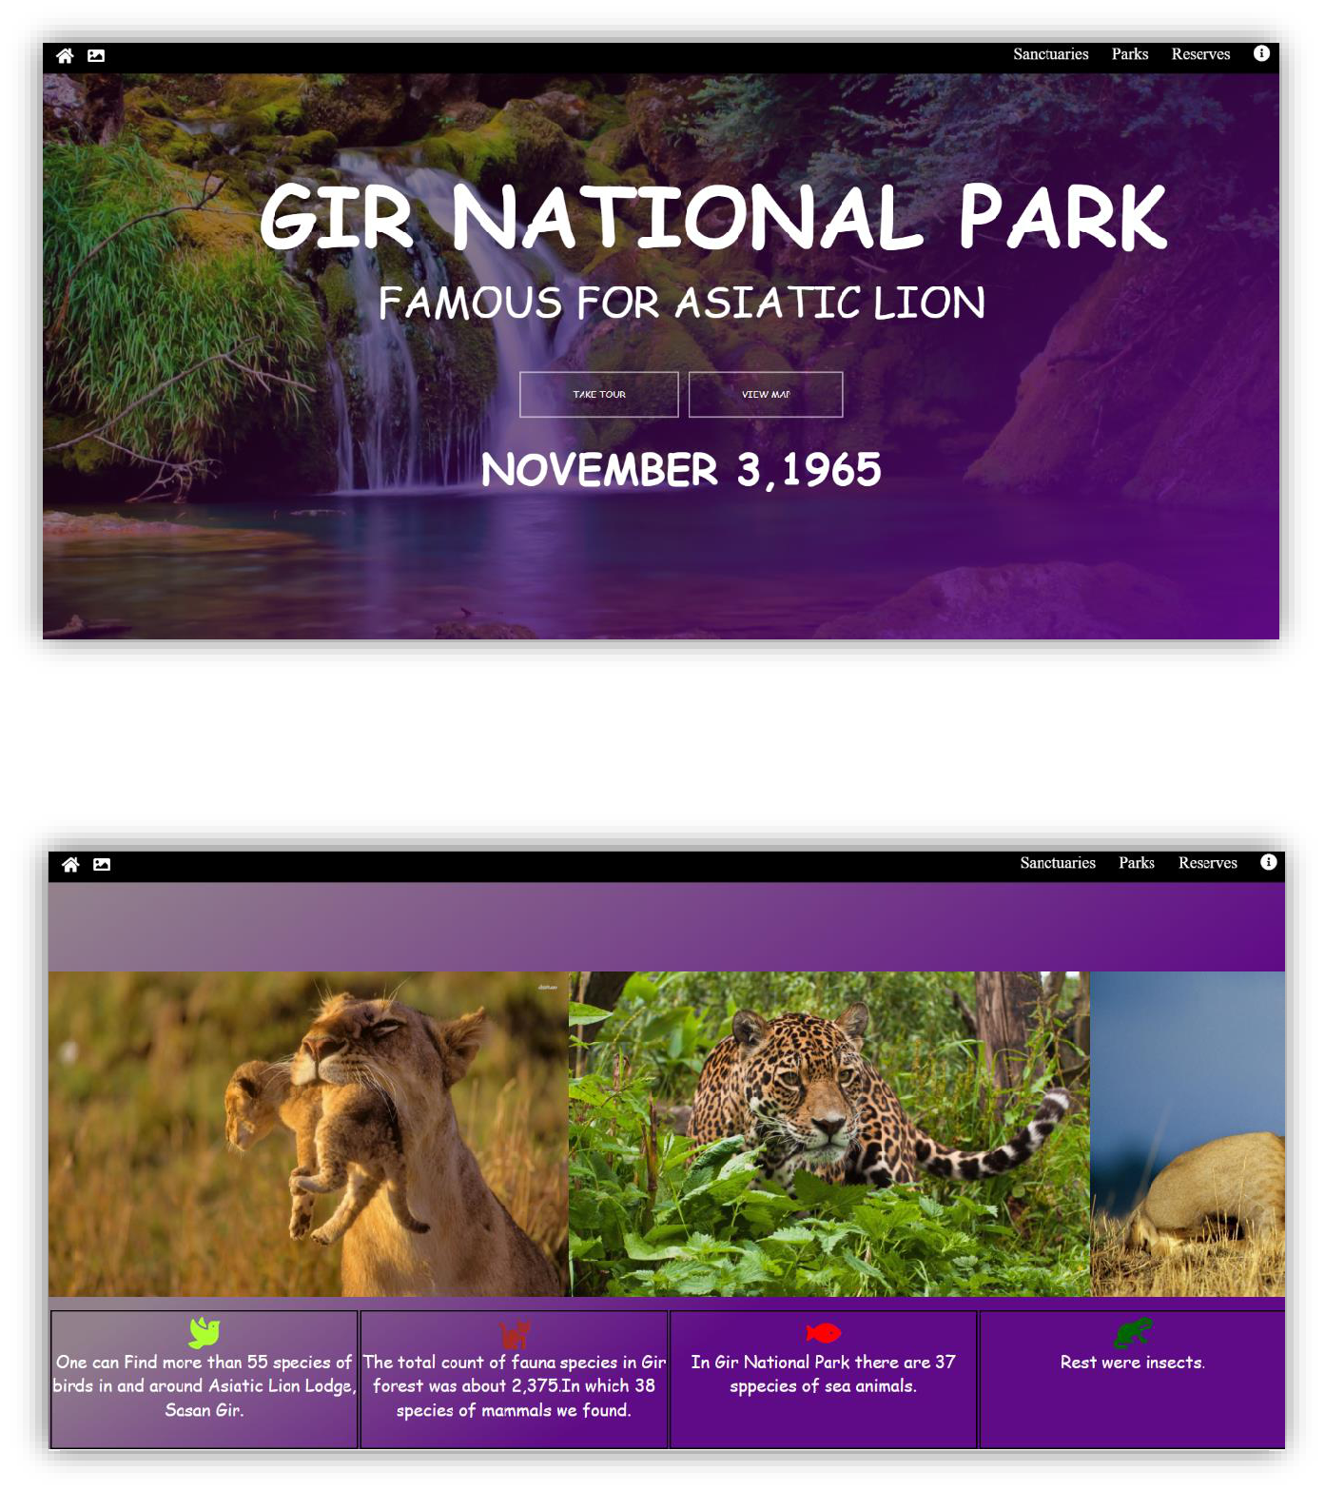

Exploration Sanctuaries (Desktop Site)

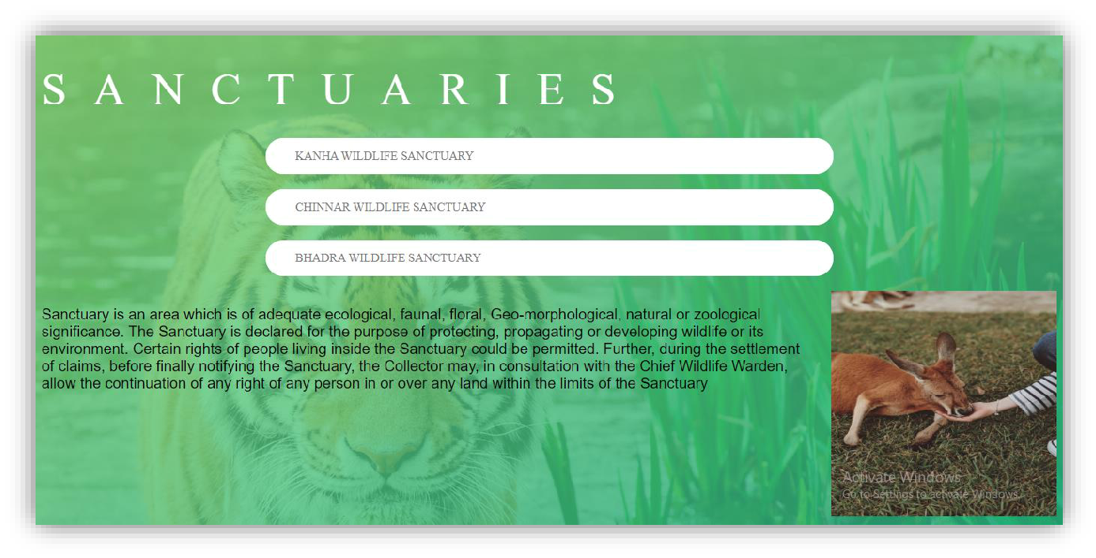

Exploration Museums (Desktop Site)

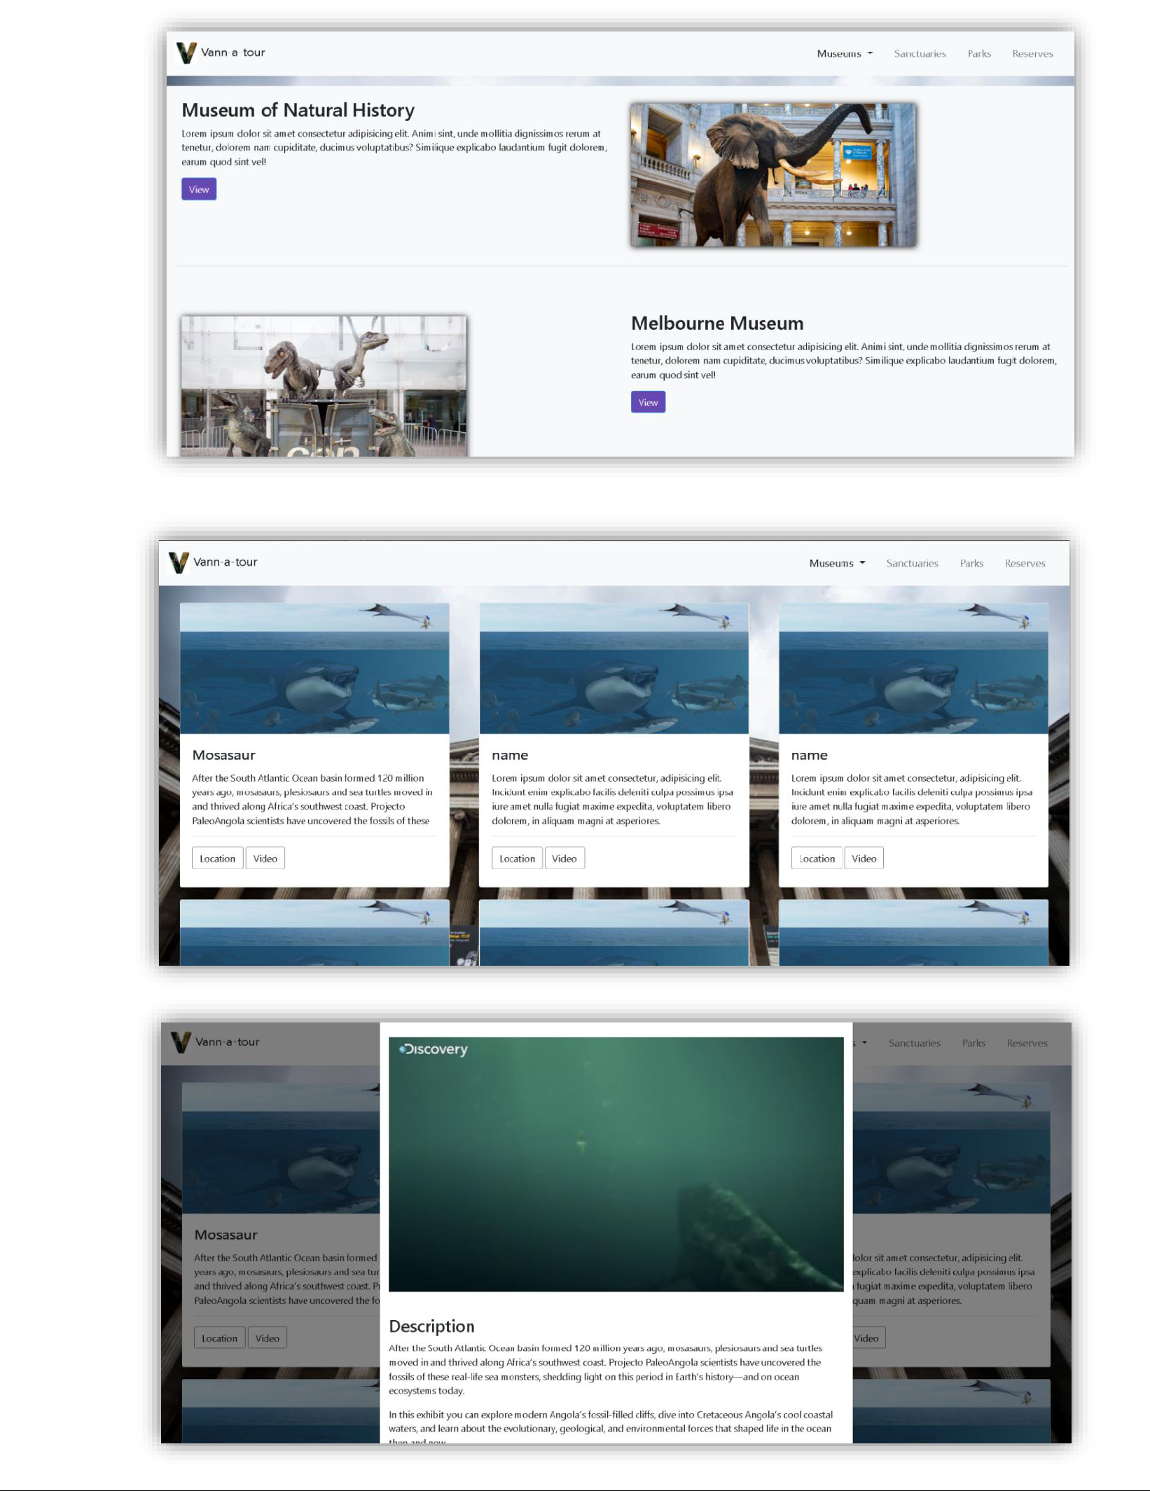

Exploration Reserves (Desktop Site)

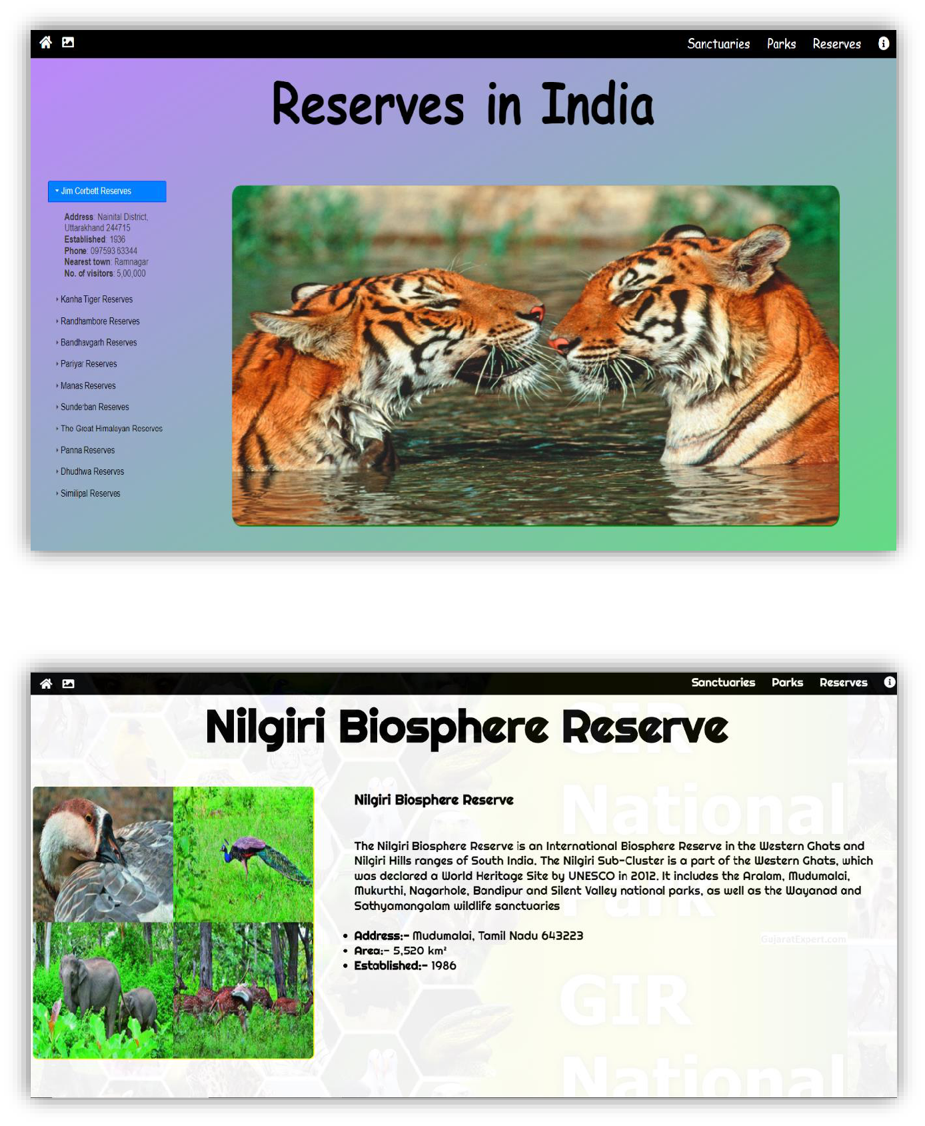

**4. CODES**



**Home-Page** (HTML-5 and Bootstrap-4)

<!DOCTYPE html>

<html lang="en">

<head>

<meta charset="UTF-8" />

<meta name="viewport" content="width=device-width, initial-scale=1.0" /> <meta http-equiv="X-UA-Compatible" content="ie=edge" /> <link rel="stylesheet" href="css/bootstrap.min.css" />

<link rel="stylesheet" href="css/styles.css" />

<link rel="stylesheet" href="css/all.css" />

<title>Home</title>

</head>

<body>

<div id="myModal" class="modal fade" role="dialog">

<div class="modal-dialog">

<!-- Modal content-->

<div class="modal-content">

<div class="modal-header">

<h4 class="modal-title text-success">Vann - a Wildlife Tour</h4>

<button type="button" class="close text-danger" data-dismiss="modal">&times;</button> </div>

<div class="modal-body">

<h5>About</h5>

<p>Front-End (INT-219) Project work</p>

<p>Assigned by: Ms. Neha Sharma</p>

<hr/>

<p ><h6 class="text-center">Built and Designed by:</h6>Shivani - 11701620<br/>Abhishek Verma - 1702561<br/>Vivek Tiwari - 11702815 <br/>Sumit Kumar - 11701545<br/>Atharva Hatekar - 11702970

<h6 class="text-secondary text-center mt-3">Lovely Professional University, India</h6></p> </div>

<div class="modal-footer">

<span class="text-secondary">2019 © an avas27 design</span><img src="assets/avas_Logo.svg" id="avasLogo">

</div>

</div>

</div>

</div>

<div class="container-fluid">

<div class="row">

<div class="col-12">

<div class="navbar navbar-light navbar-expand-md fixed-top" id="navBg"> <div class="navbar-brand navBar">

<img src="assets/vann_logo.svg" id="logo"/>

</div>

<button

class="navbar-toggler "

data-toggle="collapse"

data-target="#menu"

id="menuBut"

>

<span class="navbar-toggler-icon "></span>

</button>

<div class="collapse navbar-collapse" id="menu">

<ul class="nav navbar-nav ml-auto" id="mList">

<li class="nav-item pr-3">

<a href="#" class="nav-link navItem">Home</a>

</li>

<li class="nav-item pr-3">

<a href="#par" class="nav-link navItem">Parks</a>

</li>

<li class="nav-item pr-3">

<a href="#sanct" class="nav-link navItem">Sanctuaries</a>

</li>

<li class="nav-item pr-3">

<a href="#sanct" class="nav-link navItem">Museums</a>

</li>

<li class="nav-item pr-3">

<a href="#sanct" class="nav-link navItem">Reserves</a>

</li>

<li class="nav-item " id="x">

<a href="#" data-toggle="modal" data-target="#myModal" class="nav-link navItem">About</a> </li>

</ul>

</div>

</div>

</div>

</div>

</div>

<div class="container-fluid p-0 m-0">

<div class="row p-0 m-0">

<div class="col-12 bg p-0 m-0">

<div class="container-fluid con">

<div class="row ">

<div class="col-12">

<div class="pg1">

<img src="assets/vann_logo.svg" id="homeLogo">

</div>

</div>

<div class="col-8 offset-2 text-center">

<h3 class="mt-3 hText">a Wildlife Tour</h3>

<h5 class="mt-5 pgText"><span class="hidden">Welcome to the virtual tour of awesome wildlives across India and the world, acknowledge the greatness of amazing Parks, Sanctuaries, Museums and Reserves that protects and serves to the wildlife of our world</span><br/>Experience an awesome journey!</h5>

<a href="http://vann.ml" target="_blank" class="btn mt-5 pt-2 pb-2 pl-3 pr-3" id="tourBtn">Take me on the

tour</a>

<a href="#par" class="btn mt-5 pt-2 pb-2 pl-3 pr-3 ml-3" id="tourBtn2">Explore Wildlife</a> </div>

</div>

</div>

<img src="assets/bg-nd.svg" class="img-fluid bgImg" />

</div>

</div>

</div>

<div class="container-fluid p-0 m-0" id="par">

<div class="row p-0 m-0">

<div class="col-12 bgg p-0 m-0">

<div class="container-fluid con con2">

<div class="row">

<div class="col-12">

<div class="pg1">

<h1>National Parks</h1>

</div>

</div>

<div class="col-8 offset-2 text-center">

<h6 class="mt-0">Explore the famous National wildlife parks of India</h6> <div class="d-flex align-self-center justify-content-center mt-md-5"> <div class="park mr-md-3">

<img src="assets/gir.jpg" class="d-flex align-self-center img-thumbnail"> <h3 class="thHeading mt-3" >Gir Natinal Park</h3>

<h6>Gir Forest National Park is a <br/>wildlife sanctuary in Gujarat, India</h6> <a href="#" class="btn btn-block btn-success">Explore</a>

</div>

<div class="park mr-md-4 ml-md-4 ml-2 mr-2">

<img src="assets/Kaziranga National Park in Assam_1553856939.jpg" class="d-flex align-self-center img-

thumbnail">

<h3 class="thHeading mt-3" >Kaziranga Park</h3>

<h6>Kaziranga is a national <br/>park in the state of Assam, India</h6> <a href="#" class="btn btn-block btn-success">Explore</a>

</div>

<div class="park ml-md-3">

<img src="assets/dachigam-national-park.jpg" class="d-flex align-self-center img-thumbnail"> <h3 class="thHeading mt-3" >Dachingam Park </h3>

<h6>Dachigam National Park is <br/>located in Jammu and Kashmir, India</h6> <a href="#" class="btn btn-block btn-success">Explore</a>

</div>

</div>

</div>

</div>

</div>

<img src="assets/bg-n.svg" class="img-fluid bgImg" />

</div>

</div>

</div>

<div class="container-fluid p-0 m-0" id="sanct">

<div class="row p-0 m-0">

<div class="col-12 bggg p-0 m-0">

<div class="container-fluid con con3" style="top:100px;">

<div class="row " >

<div class="col-12">

<div class="pg1">

<h1>Sanctuaries &nbsp; Museums &nbsp;Reserves</h1>

</div>

</div>

<div class="col-8 offset-2 text-center">

<h6 class="mt-0">Explore the famous National wildlife parks of India</h6> <div class="d-flex align-self-center justify-content-center mt-md-5"> <div class="park mr-md-3">

<img src="assets/kanha.jpg" class="d-flex align-self-center img-thumbnail"> <h3 class="thHeading mt-3" >Kanha Sanctuary </h3>

<h6>Kanha National Park is <br/>one of the largest tiger <br/>reserves of Madhya Pradesh, India</h6> <a href="#" class="btn btn-block btn-success">Explore</a>

</div>

<div class="park mr-md-4 ml-md-4 ml-2 mr-2">

<img src="assets/mz.jpg" class="d-flex align-self-center img-thumbnail"> <h3 class="thHeading mt-3" >Kaziranga Park</h3>

<h6>It is a natural history museum <br/>located on the National Mall in <br/>Washington, D.C., United

States.</h6>

<a href="#" class="btn btn-block btn-success">Explore</a>

</div>

<div class="park ml-md-3">

<img src="assets/nandadevi.png" class="d-flex align-self-center img-thumbnail"> <h3 class="thHeading mt-3" >Nandadevi Reserve</h3>

<h6>Nanda Devi Biosphere is situated<br/> around the peak of Nanda Devi<br/> in Uttarakhand, northern

India</h6>

<a href="#" class="btn btn-block btn-success">Explore</a>

</div>

</div>

</div>

</div>

</div>

<img src="assets/bg.svg" class="img-fluid bgImg" />

</div>

</div>

</div>

<div class="container-fluid">

<div class="row">

<div class="col-12 footer">

<div class="container-fluid">

<div class="row">

<div class="col-6 ">

<ul id="ful" class="list-unstyled mt-2">

<li class="list-inline-item">

<a href="#" class="nav-link text-secondary">Home</a>

</li>

<li class="list-inline-item">

<a href="#" class="nav-link text-secondary">Parks</a>

</li>

<li class="list-inline-item">

<a href="#" class="nav-link text-secondary">Sanctuaries</a>

</li>

<li class="list-inline-item">

<a href="#" class="nav-link text-secondary">Museums</a>

</li>

<li class="list-inline-item">

<a href="#" class="nav-link text-secondary">Reserves</a>

</li>

<li class="list-inline-item">

<a href="#" class="nav-link text-secondary">About</a>

</li>

</ul>

</div>

<div class="col-2 offset-4">

<ul id="ful" class="list-unstyled mt-2">

<span class="text-secondary">Follow us: </span>

<li class="list-inline-item">

<a href="#" class="nav-link text-secondary">

<i class="fab fa-youtube"></i>

</a>

</li>

<!-- <li class="list-inline-item">

<a href="#" class="nav-link text-secondary"><i class="fab fa-facebook-square"></i></a> </li> -->

<li class="list-inline-item">

<a href="#" class="nav-link text-secondary"><img src="assets/avas_Logo.svg" id="avasLogo"></a> </li>

</ul>

</div>

</div>

<div class="row">

<div class="col-6 offset-3 text-center text-secondary">

2019 © vann - wildlife tour &nbsp;&nbsp;(an avas27 venture)

</div>

</div>

</div>

</div>

</div>

</div>

</div>

<!-- <script

src="https://maxcdn.bootstrapcdn.com/bootstrap/3.3.7/js/bootstrap.min.js"

integrity="sha384-Tc5IQib027qvyjSMfHjOMaLkfuWVxZxUPnCJA7l2mCWNIpG9mGCD8wGNIcPD7Txa"

crossorigin="anonymous"

></script> -->

<script src="JS/jquery.slim.min.js"></script>

<script src="JS/bootstrap.min.js"></script>

<script src="JS/jquery.min.js"></script>

<script src="JS/jquery.waypoints.min.js"></script>

<script src="JS/all.js"></script>

<script src="JS/custom.js"></script>

</body>

</html>

**AngularJS:**

var avasModule = angular.module("avasModule", ["ngRoute"]);

avasModule.config([

"$routeProvider",

function($routeProvider) {

$routeProvider

.when("/home", {

templateUrl: "html/landingPage.html"

})

.when("/land", {

templateUrl: "html/homePage.html"

})

.when("/park", {

templateUrl: "html/park.html"

})

.when("/park2", {

templateUrl: "html/park2.html"

})

.otherwise({ redirectTo: "/home" });

}

]);

**5. VERSION CONTROL AND HOSTING**



**5.1 Version Control**

Git and GitHub version control systems are used to ensure error and bug free coding on both local and remote repositories respectively.

Link for GitHub:

* HomePage

<https://github.com/avas27/Wildlife-a-Resposnive-Modern-Website->

* Tour/Game

<https://github.com/avas27/Vann-a-Wildlife-Exploration>

**5.2 Hosting**

Our Tour / Game website has been hosted online at <http://vann.ml/#!/home>

**5.3 YouTube**

Our Website Demonstration video are available on YouTube at following links:

<https://www.youtube.com/channel/UCfqU1zw2n7_dzWskNOep-Ww/videos>